CSE/EEE 120

Lab 3 Answer Sheet

Registers, Counters and the “Brainless CPU”

Name: ElHadji Omar Bane

Instructor/Time: Doctor Steve @ 10:30 Tuesday & Thursday

Date: 3/12/2024

**Task 3-1: Build and Test a 4-Bit D Register with Enable**

**Include a picture of your Digital circuit here:**

**Please comment on the single biggest issue you were facing when designing the circuit.**

The biggest issue I had was understanding how the Set and four_bit_mux contribute to the circuit.

**Include a picture of your GTKWave waveforms (timing diagram) here:**

**Did the circuit behave as expected? If no, what was wrong?**

It behaved as expected.

**Please comment on the single biggest issue you were facing when simulating the circuit.**

The biggest issue I had was comprehending how the clock was being utilized by the circuit.

**Task 3-2: Build and Test a 4-Bit UP Counter**

**Include a picture of your Digital circuit here:**

**Please comment on the single biggest issue you were facing when designing the circuit.**

The biggest issue I faced was understanding how the q increases before the incrementer’s input changes.

Did the circuit behave as expected? If no, what was wrong?

Please comment on the single biggest issue you were facing when simulating the circuit.

**Task 3-3: Create a 4-Bit RAM with 16 4-Bit Words**

**Include a picture of your Digital circuit here:**

**Please comment on the single biggest issue you were facing when designing the circuit.**

The biggest issue I faced was understanding what OIs needed to be 4 bits.

**Did the circuit behave as expected? If no, what was wrong?**

The circuit behaved as expected.

**Please comment on the single biggest issue you were facing when simulating the circuit.**

The biggest issue I had was navigating to the different addressed due to digital’s UI.

**Task 3-4: Build and Test the Brainless Central Processing Unit**

**Include a picture of your Digital circuit here:**

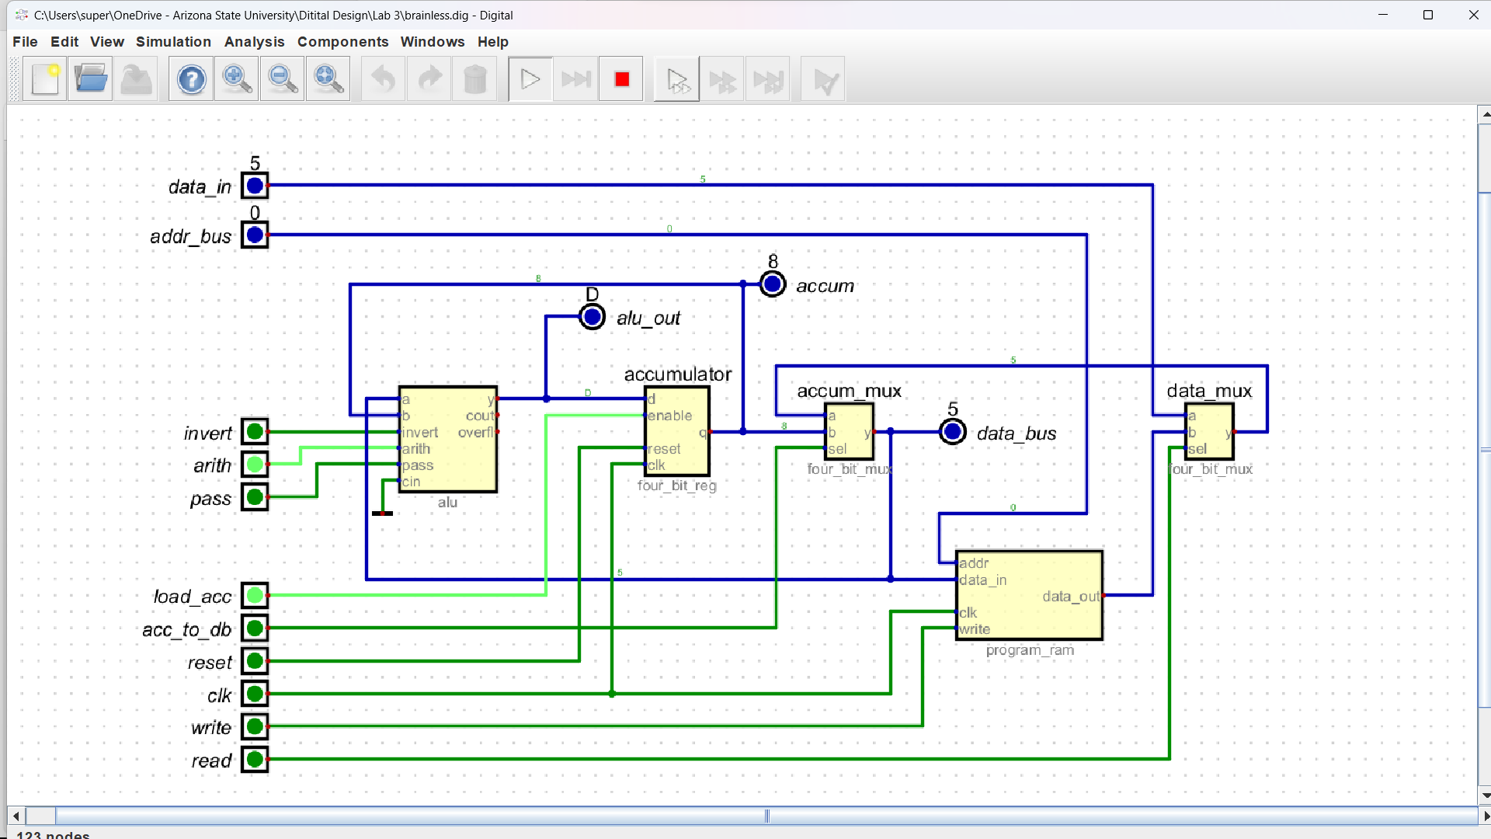

**Please comment on the single biggest issue you were facing when designing the circuit.**

The biggest issue I faced was understanding where wires went and how the individual circuits came together to behave like a CPU.

**Did the circuit behave as expected? If no, what was wrong?**

The circuit behaved as expected .

**Please comment on the single biggest issue you were facing when simulating the circuit.**

The biggest issue I faced was learning how to operate the CPU.

**Task 3-5: Simulate the Brainless Central Processing Unit**

**Include a picture of your GTKWave waveforms (timing diagram) here:**

**Did the circuit behave as expected? If no, what was wrong?**

It worked as expected.

**Please comment on the single biggest issue you were facing when simulating the circuit.**

The biggest issue I faced was troubleshooting and finding out why I was having issues with the ram.

**Task 3-6: Create Additional Tests**

As shown in the manual, paste the test_vals you used for each of the tests here. Be sure to note which each set of test_vals goes with each test.

## Brainless_ext_write.v

test_vals[0] = 28'h0_0_0_0_0_0_2; // reset - this should always be the first vector

test_vals[1] = 28'h0_F_0_F_5_0_2; // get 3 into the accumulator

test_vals[2] = 28'h0_C_0_C_A_0_2; // add 3+5 and store in the accumulator

test_vals[3] = 28'h0_3_0_3_F_0_2; // do nothing the rest of the way

test_vals[4] = 28'h0_0_0_0_0_0_1;

test_vals[5] = 28'h0_F_0_0_5_0_1;

test_vals[6] = 28'h0_C_0_0_A_0_1;

test_vals[7] = 28'h0_3_0_0_F_0_1;

## Brainless_int_write.v

test_vals[0] = 28'h2_2_4_2_0_5_0;

test_vals[1] = 28'h2_2_2_0_0_0_A;

test_vals[2] = 28'h4_2_6_2_C_5_0;

test_vals[3] = 28'h4_4_4_0_C_0_A;

test_vals[4] = 28'h0_0_0_0_0_0_4;

test_vals[5] = 28'h0_2_0_0_0_0_1;

test_vals[6] = 28'h0_4_0_0_C_0_1;

## Brainless_alu.v

test_vals[0] = 28'h2_2_4_2_0_5_0;

test_vals[1] = 28'h4_2_6_2_0_5_0;

test_vals[2] = 28'h0_0_0_0_0_0_4;

test_vals[3] = 28'h7_7_E_7_0_5_0;

test_vals[4] = 28'h4_3_1_3_0_D_0;

If you changed your circuit since you took the screenshot for Task 3-4, take another and replace the screenshot in Task 3-4.

**Include a picture of your GTKWave waveforms here (one per required test):**

## Brainless_ext

## Brainless_int

## Brainless_alu

**Please comment on the single biggest issue you were facing when designing the circuit.**

The biggest issue I faced was keeping the wires neat.

**Did the circuit behave as expected? If no, what was wrong?**

It behaved as expected.

**Please comment on the single biggest issue you were facing when simulating the circuit.**

The biggest issue I faced was translating the binary values into the stim files.

**Task 3-7: Create a video and submit your report**

Record a short video showing your schematics in Digital and your waveforms in GTKWave. Be sure to show yourself in the video and show your screen. Explain how your circuit works – you need to convince the grader you did the lab and understand it! **Copy and paste the link to your video below. Make sure the link is working and pointing to the correct video. Remember to include the password if required. Do NOT upload your video to Canvas. It is recommended that you use Zoom to record to the cloud, pasting the link and password below.** If your circuit is not working as expected, explain in the video how it is not working and why you think it is not working.

**Video Link:**

**At the beginning of your recording, say your name and the lab name. Be brief in your recording. Submit the completed template to Canvas.**

**Make sure all your files are in the Lab3 directory. Create a zip file of the Lab3 directory. Remember to turn in the zip file and your completed template on Canvas!**

**Do not include the video in the zip file! This makes the file very large and you run the risk of the zip file not uploading or taking so long to upload that your submission will be late. Remember that the submission is dated at the time the upload completes, not when it starts!**

Lab 3: Lab Report Grade Sheet

|  |  |
| --- | --- |
| **Name:** |  |

**NOTE: You submit the zip file in order to show your work.  
If the zip file is not submitted there is a 5 point deduction!**

## Instructor Assessment

|  |  |  |
| --- | --- | --- |
| **Grading Criteria** | **Max Points** | **Points Lost** |
| **Description of Assigned Tasks, Work Performed & Outcomes Met** |  |  |
| Task 3-1: Build and Test a 4-Bit D Register with Enable | 10 |  |
| Task 3-2: Build and Test a 4-Bit UP Counter | 10 |  |
| Task 3-4: Build and Test the Brainless Central Processing Unit | 10 |  |
| Task 3-5: Simulate the Brainless Central Processing Unit | 10 |  |
| Task 3-6: Create Additional Tests | 10 |  |
| Task 3-7: Create a video and submit your report | 10 |  |
|  | **Points Lost** |  |
| Lab Score (60 points total) | **Late Lab** |  |
|  | **Lab Score** |  |